产 品 规 格 书
Product Specification Sheet

TOP-BIDI-XFP-ER-40A
RoHS Compliant 10Gb/s Tx1270nm/Rx1330nm 40km Optical Transceiver
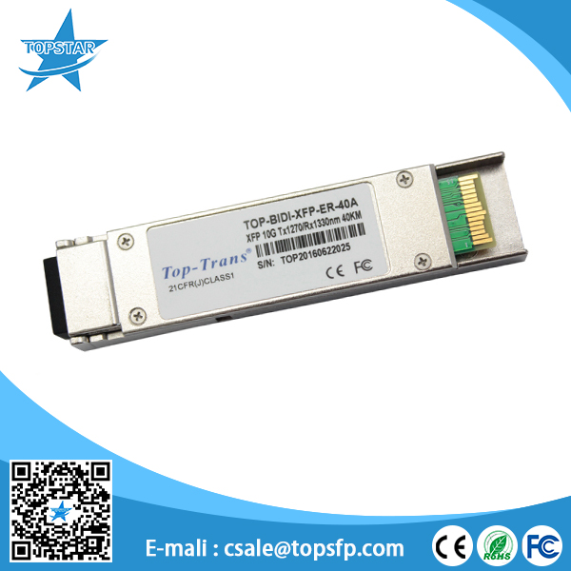

PRODUCT FEATURES
● Hot pluggable
● Support 9.95Gb/s to 11.1Gb/s bit rates
● Below<1.5w power consumption
● XFPMSA package with LC connector
● Digital Diagnostic Monitor Interface
● Very low EMI and excellent ESD protection
● Un-cooled 1270nm DFB laser
● +3.3V single power supply
● operating temperature range 0°C to 70°C
● No reference clock requirement

APPLICATIONS
●10GBASE-BX10.3125Gb/s Ethernet
●10GBASE-BX9.953Gb/s Ethernet
●SONETOC-192 &SDHSTM I-64.1

STANDARD
● XFPMSA Compliant
● SFF-8472 reversion 9.5 compliant
● IEEE802.3-2005 compliant
● Telcordia GR-468-CORE compliant
● FCC47CFR Part15,ClassB compliant
● FDA21CFR1040.10 and 1040.11,class1 compliant
● RoHS compliant

PRODUCT DESCRIPTIONS
XFP 10G 40KM 1270 transceivers are designed for 10G Ethernet 10GBASE-ER/EWper802.3 ae and 10GSOIOC-192/SDHSTM-64,and it can support data-rate from 9.953Gb/s to 11.1Gb/s. Digital diagnostics are available via I2C interface as specified in the XFPMSA. The transceiver designs are optimized for high performance and cost effective to supply customers the best solutions for data-comand telecom applications.

FUNCTIONAL DIAGRAM
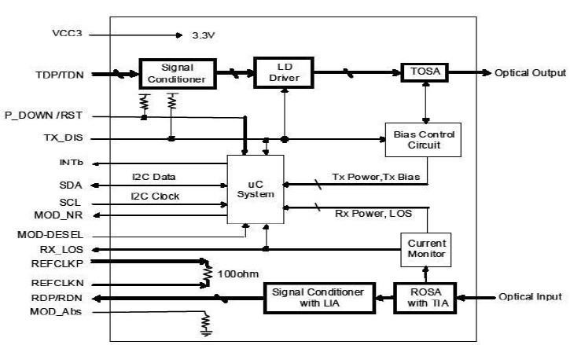

ABSOLUTE MAXIMUM RATINGS
Parameter | Symbol | Min. | Max. | Unit | Note
Supply Voltage | Vcc | -0.5 | 4.0 | V
Storage Temperature |  | -40 | 85 | °C
Relative Humidity |  |  | 85 | %
Note: Stress in excess of the maximum absolute ratings can cause permanent damage to the module

GERERAL OPERATING CHARACTERISTICS
Parameter |  | Symbol | Min. | Typ | Max. | Unit | Note
Data Rate | Ethernet |  |  | 10.3125 |  | Gb/s
 | Fiber Channel |  |  | 9.953
Supply Voltage |  | Vcc | 3.14 | 3.3 | 3.46 | V
 |  | Vcc |  |  |  | V
Supply Current |  | Icc5 |  |  |  | mA
 |  | Icc3 |  |  | 400 | mA
Operating Case Temp. |  | Tc | 0 |  | 70 | °C

ELECTRICAL INPUT/OUTPUT CHARACTERISTICS
● Transmitter

Parameter |  | Symbol | Min. | Typ | Max. | Unit | Note
Diff. input voltage swing |  |  | 120 |  | 820 | mVpp | 1
Tx Disable input | H | VIH | 2.0 |  | Vcc+0.3 | V
 | L | VIL | 0 |  | 0.8
Tx Fault output | H | VOH | 2.0 |  | Vcc+0.3 | V | 2
 | L | VOL | 0 |  | 0.8
Input Diff. Impedance |  | Zin |  | 100 |  | Ω
● Receiver

Parameter |  | Symbol | Min. | Typ | Max. | Unit | Note
Diff. output voltage swing |  |  | 340 | 650 | 800 | mVpp | 3
Rx LOS Output | H | VOH | 2.0 |  | Vcc+0.3 | V | 2
 | L | VOL | 0 |  | 0.8
Note1)TD+/-are internally AC coupled with 100Ω differential termination inside the module.
Note2)Tx Fault and Rx LOS are open collector outputs, which should be pulled up with 4.7kto10kΩ
resistors on the host board. Pull up voltage between2.0VandVcc+0.3V.
Note3)RD+/- outputs are internally AC coupled, and should be terminated with100Ω(differential)at the user
SERDES.

OPTICAL CHARACTERISTICS
● Transmitter(0~70 @10.3125Gb/s)

Parameter | Symbol | Min. | Typ | Max. | Unit | Note
Operating Wavelength |  | 1260 | 1270 | 1280 | nm
Ave. output power(Enabled) | Po | -1 |  | 3 | dBm | 1
Extinction Ratio | ER | 3.5 |  |  | dB | 1
RMS spectral width | Δλ |  |  | 1 | nm
Rise/Fall time(20%~80%) | Tr/Tf |  |  | 50 | ps | 2
Optical modulation amplitude | OMA | -5.1 |  |  | dBm
Dispersion penalty |  |  |  | 2 | dB
Output Optical Eye | IEEE802.3-2005Compliant

● Receiver(0~70 @10.3125Gb/s)

Parameter | Symbol | Min. | Typ | Max. | Unit | Note
Operating Wave length |  | 1320 | 1330 | 1340 | nm
Sensitivity | Psen |  |  | -16 | dBm | 3
Min. overload | Pimax | 0 |  |  | dBm
LOS Assert | Pa | -30 |  |  | dBm
LOS De-assert | Pd |  |  | -18 | dBm
LOS Hysteresis | Pd-Pa | 0.5 |  | 4 | dB
Note1)Measured at10.3125b/s with PRBS231–1NRZ test pattern.
Note2)20%~80%
Note3)Under the ER worst case, measured at10.3125Gb/s with PRBS231 -1NRZ test pattern for BER<1x10-12

SERIAL INTERFACE FOR ID AND DDM
The XFP modules implement the 2-wire serial communication protocol as defined in the XFPMSA. The serial ID information of the XFP modules and Digital Diagnostic Monitor parameters can be accessed through the I2C interface at address A0handA2h. The memory is mapped in Table1. Detailed ID information(A0h) is listed in Ta-ble2.And the DDM specification(A2h) is described in Table3. For more details of the memory map and byte definitions, please refer to the SFF-8472(Rev9.3,Aug.2002), “Digital Diagnostic Monitoring Interface for Optical Transceivers”. The DDM parameters have been internally calibrated.
Table1.DigitalDiagnosticMemoryMap(Specific Data Field Descriptions)
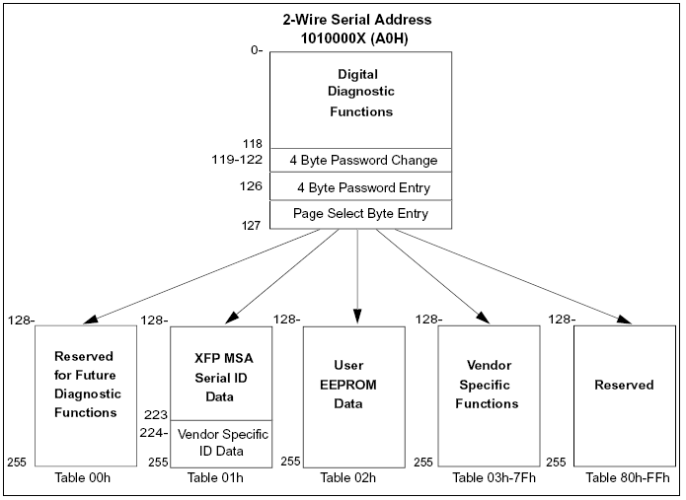

PIN DEFINITIONS AND FUNCTIONS
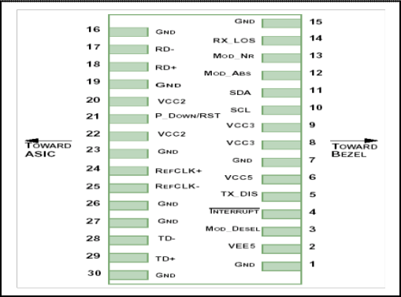

PIN# | Name | Function | Name/Description | Notes
1 |  | GND | Module Ground | 1
2 |  | VEE5 | Optional-5.2VPowerSupply (Not required)
3 | LVTTL-I | MOD_DESEL | Module De-select;When held low allows the module to respond to2-wire serial interface
4 | LVTTL-O | INTb | Interrupt; Indicates presence of an important condition which can bereadviathe2-wireserialinterface | 2
5 | LVTTL-I | TX_DIS | Transmitter Disable; Turns off transmitter laser output
6 |  | VCC5 | +5VPowerSupply(Not required)
7 |  | GND | Module Ground | 1
8 |  | VCC3 | +3.3VPowerSupply
9 |  | VCC3 | +3.3VPowerSupply
10 | LVTTL-I/O | SCL | 2-WireSerialInterface Clock | 2
11 | LVTTL-I/O | SDA | 2-WireSerialInterface Data Line | 2
12 | LVTTL-O | MOD_ Abs | Indicates Module is not present. Grounded in the Module | 2
13 | LVTTL-O | MOD_NR | Module Not Ready; Indicating Module Operational Fault | 2
14 | LVTTL-O | RX_LOS | Receiver Loss Of Signal Indicator | 2
15 |  | GND | Module Ground | 1
16 |  | GND | Module Ground | 1
17 | CML-O | RDN | ReceiverInverted DataOutput
18 | CML-O | RDP | Receiver Non-InvertedDataOutput
19 |  | GND | Module Ground | 1
20 |  | VCC2 | +1.8VPowerSupply(Not required). | 3
21 | LVTTL-I | P_DOWN/RST | Power down; When high, requires the module to limit power consumptionto1.5Worbelow.2-Wireserialinterfacemustbe functional in the low power mode.
21 | LVTTL-I | P_DOWN/RST | Reset; The falling edge initiates a complete reset of the module includingthe2-wire serial interface, equivalent toapower cycle.
22 |  | VCC2 | +1.8VPowerSupply(Not required) | 3
23 |  | GND | Module Ground | 1
24 | PECL-I | REFCLKP | Not used, internallyterminatedto50ohm (100ohm diff). | 4
25 | PECL-I | REFCLKN | Not used, internallyterminatedto50ohm (100ohm diff). | 4
26 |  | GND | Module Ground | 1
27 |  | GND | Module Ground | 1
28 | CML-I | TDN | Transmitter Inverted Data Input
29 | CML-I | TDP | Transmitter Non-Inverted Data Input
30 |  | GND | Module Ground | 1
Note:1.Module ground pins GND are isolated from the module case and chassis ground within the module.
2.Open collector; Shall be pulled up with4.7K-10Kohms to a voltage between3.15Vand3.6V on the host board.
3.The pins are open within module.
4.Reference Clock is not required.

TYPICAL INTERFACE CIRCUIT
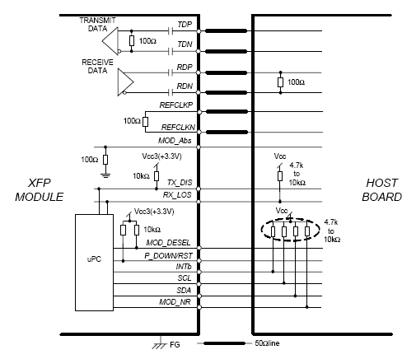

PACKAGE DIMENSIONS

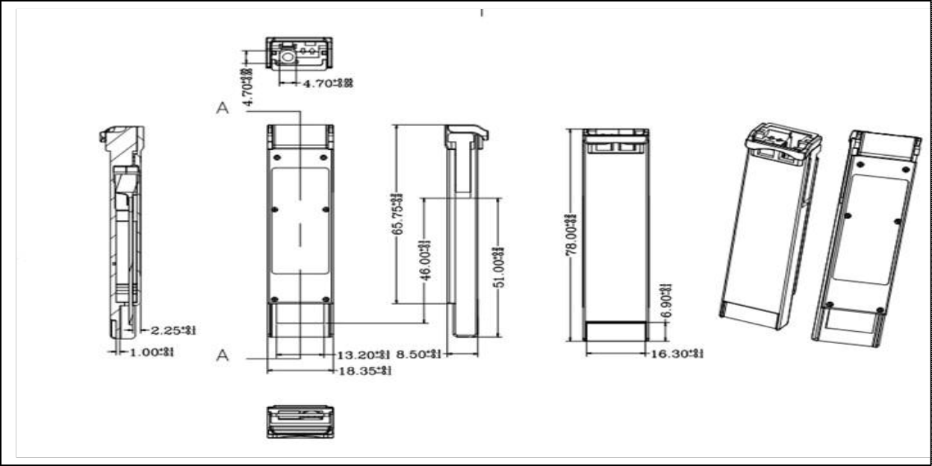

ORDERING INFORMATION
Part Number | Description
TOP-BIDI-XFP-20A | XFP BiDi,10.3125Gbps,1270nm,20KM,0~70℃,with DDM
TOP-BIDI-XFP-20B | XFP BiDi,10.3125Gbps,1330nm,20KM,0~70℃,with DDM
TOP-BIDI-XFP-ER-40A | XFP BiDi,10.3125Gbps,1270nm,40KM,0~70℃,with DDM
TOP-BIDI-XFP-ER-40B | XFP BiDi,10.3125Gbps,1330nm,40KM,-5~70℃,with DDM
TOP-BIDI-XFP-ZR-80A | XFP BiDi,10.3125Gbps,1270nm,80KM,-5~70℃,with DDM
TOP-BIDI-XFP-ZR-80B | XFP BiDi,10.3125Gbps,1330nm,80KM,-5~70℃,with DDM

Topstar Technology Industrial Co., Ltd

Add: F5, Rongcheng Building, 28 Yayuan Road Wuhe Community, BanTian Street, Shenzhen, China

Tel: +86 755 8255 2969 Email:lisa@topsfp.com

Skype: lisalin6565 WhatsApp: +86 13798265065

WeChat: 251081707
Facebook and Linked in: Topstar Technology Industrial Co., Ltd

